**Internet and Web Programming**

# Aim:

To create an XML file for student details, generating a schema for it and validating it using XML Copy Editor

# Procedure:

* Create the xml file using xml copy editor

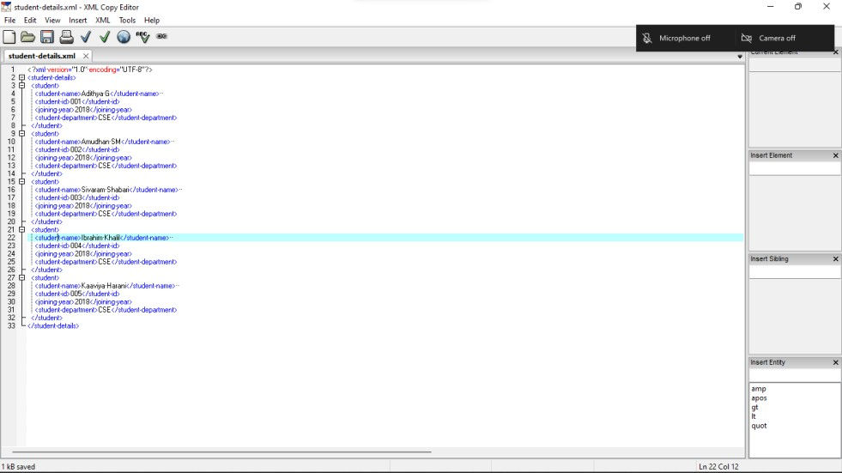

* Click on XML > Create Schema

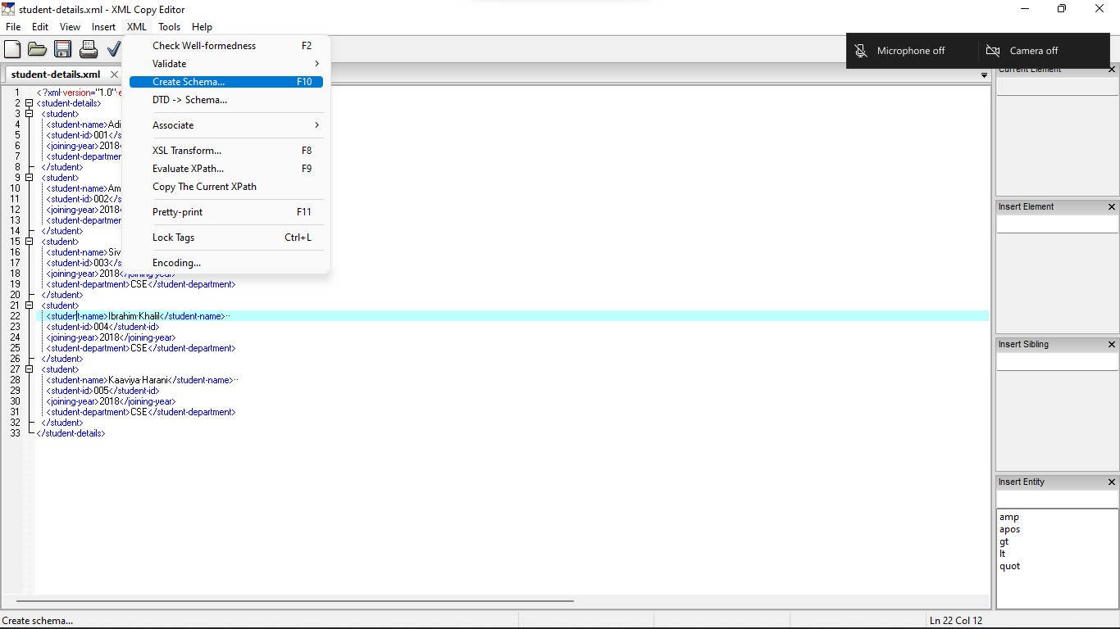

* Click on DTD and then OK

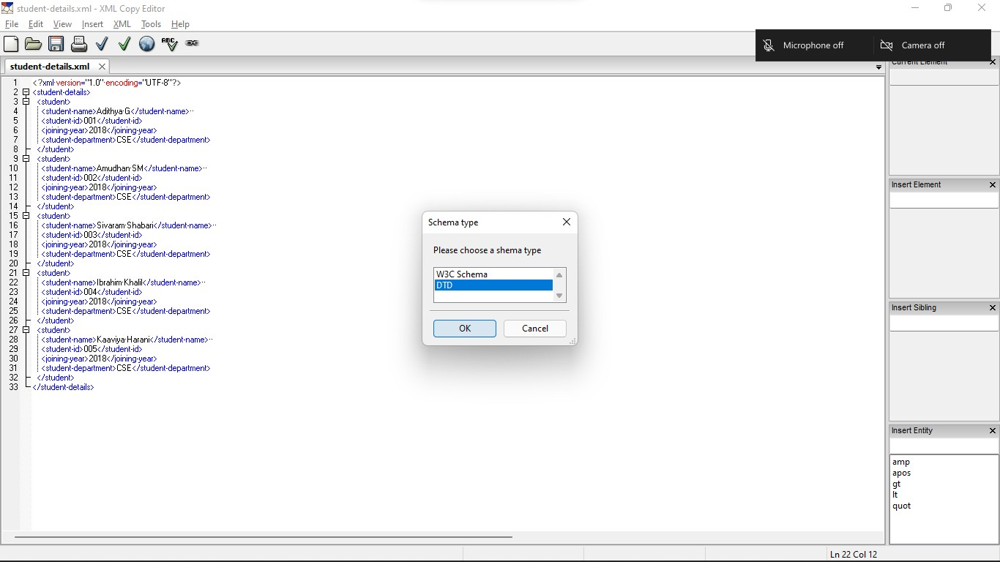

* The schema is generated

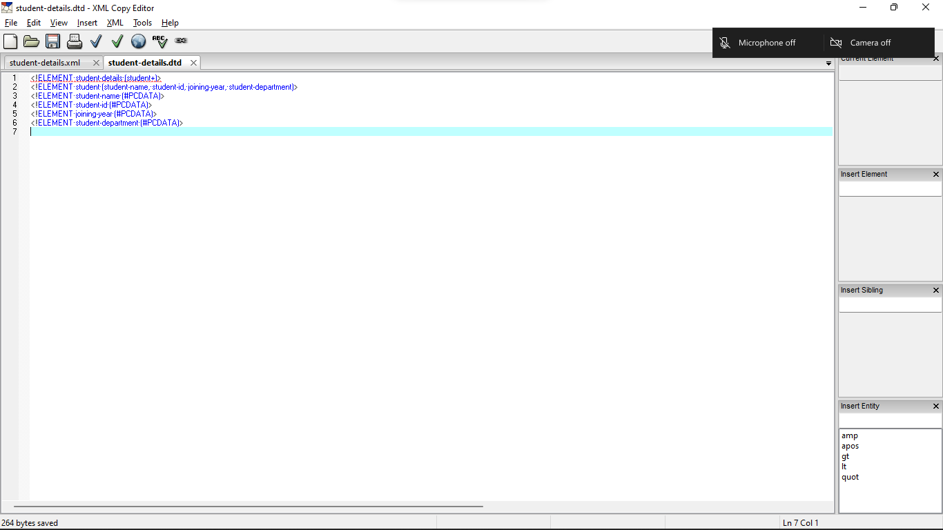

* Go to the .xml file click on XML > Associate and link the generated .dtd file

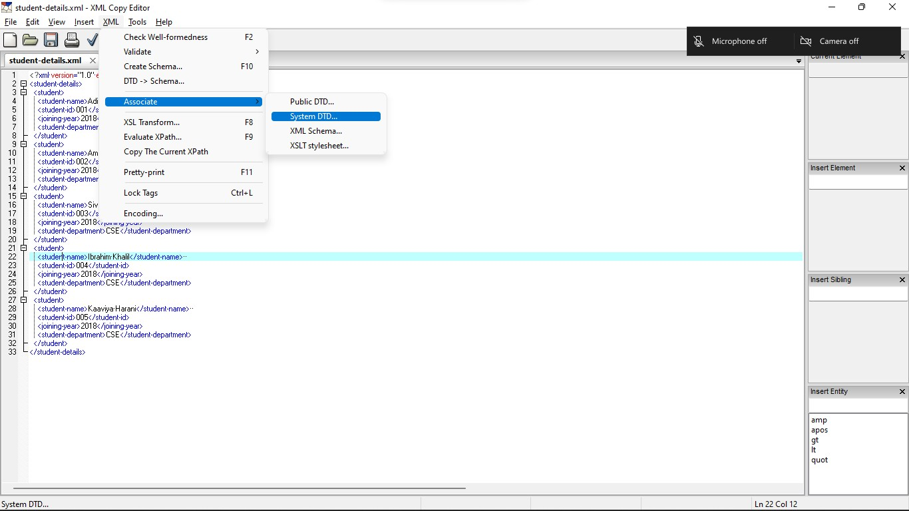

* Click on validate schema and a pop should appear at the bottom of the screen

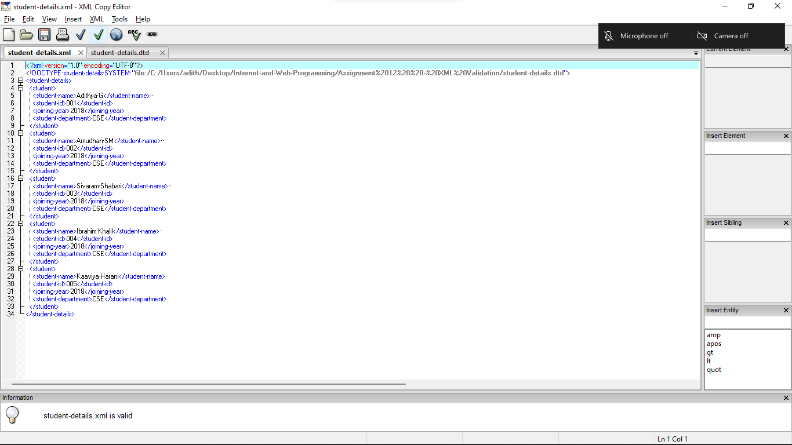

# Result:

Thus, an XML document and its schema were created and validated using XML Copy Editor